

**LINE FOLLOWER ROBOT**

**Supervisor:** Yrd. Doç. Dr. Orhan GAZİ

**Prepared by:**

**Fatih DEMİRCİ Serkan GÖRSE**

***CONTENTS***

* ***What Is a Line Follower Robot ..........................................................4***

***How does it work ....................................................................................5***

* Sensor Circuit .................................................................................................5
* CNY70 Sensor .................................................................................................6
* 74HC14 (Schmitt trigger ) ...............................................................................6
* Components of Sensor Circuit ........................................................................6
* Tips About Sensor ...........................................................................................7
* ***Motor Interface and Control Circuit ....................................................7***
* PIC 16F628A ....................................................................................................8
* L293D (Motor Interface) .................................................................................8
* Crystal Oscillator .............................................................................................9
* Capacitor .........................................................................................................9
* Components of Motor Interface and Control Circuit .....................................9
* ***Voltage Regulator Circuit ....................................................................9***
* 7805 ...............................................................................................................10
* Components of Voltage Regulator Circuit......................................................10
* ***Programming ....................................................................................10***
* ***Mechanical Part ................................................................................11***
* ***Step By Step Making a Line Follower Robot .......................................12***
* ***Assembly Codes .................................................................................12***

***LIST OF FIGURES***

*Figure 1, line follower robot* ......................................................................................................4

*Figure 2, Microprocessor’s decisions.........................................................................................4*

*Figure 3, Sensor Circuit .............................................................................................................5*

*Figure 4, Printed Sensor Circuit..................................................................................................5*

*Figure 5, CNY70 Sensor..............................................................................................................6*

*Figure 6, 74HC14 (Schmitt trigger)............................................................................................6*

*Figure 7, Placement of Sensors..................................................................................................7*

*Figure 8, Control Circuit.............................................................................................................7*

*Figure 9, Printed Control Circuit................................................................................................8*

*Figure 10, PIC 16F628A.............................................................................................................8*

*figure 11, L293D (Motor Control Unit ).....................................................................................8*

*figure 12, Voltaj Regulator Circuit.............................................................................................9*

*figure 13,Printed Voltaj Regulator Circuit................................................................................10*

*Figure 14, 7805.......................................................................................................................10*

*Figure 15, Simple Flow Cart....................................................................................................10*

*Figure 16, Mechanical Part a ................................................................................................11*

*Figure 16, Mechanical Part b .................................................................................................11*

*Figure 17, Assembly Codes.....................................................................................................12*

**What is a line follower Robot ?**

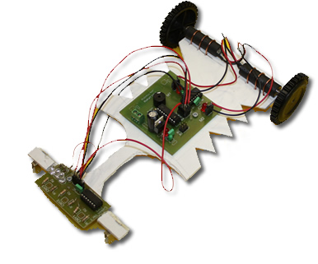

A line follower robot is an autonomous mobile robot that can follow a path. The path can be a white path on a black surface or a black path on a white surface. Line follower robots are usually entertainment hobby robots. However, they can be improved and used in industry  in order to carry some loads on a definite path or in markets and cafes for similar purposes.The important point of building a line follower robot is a good control that - *Figure 1, line follower robot* is sufficient to follow the path as fast as possible. In this project our sensors spread infrared lights and they collect reflection infrared ligths thanks to light detector after that it changes voltage level according to intensity of ligths.For seeing this reflection line colour must be white or black.If line color is black, reflection will be minumum but if it is white, reflection will be maximum.For the best result line is white, ground is black or vice versa.The outputs which come from sensors are analog.We must convert these analog signal to digital because our microprocessor works with only digital signal. Microprocessor decides next movement according to these signals and it commands motors.Microprocessor’s decisions can be like this.

 If third sensor is on the line that means root is left side of the line.Because of this until second sensor see the line turn right.



 In this part second sensor is on the line.That means robot will go straight on.

In this part first sensor is on the line that means robot is right side of the line until second sensor see line turn left.

*figure 2, Microprocessor’s decisions*

This three steatments are enough to control a line follower robot for a system which includes three sensors. More sensors can be used with very different and comlex confugration to take good results.But with more sensors, more steatments must be controlled and thus the program must have more details to afford these requirement.If the program has more details, the system responses time will be long and robot will not be agile.This is the bad side of the using more than three sensors.In this project system response time is important because of this. you shouldn’t use more than three sensors if it is not necessary.

**How does it work ?**

* 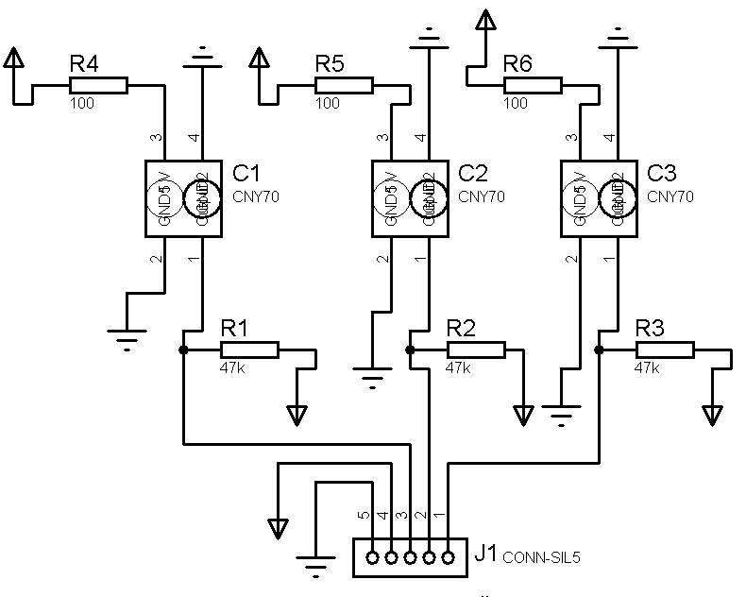**Sensor Circuit**

The CNY70 is a reflective sensor that includes an infrared led emitter and phototransistor in a leaded package which blocks visible light.The emitted IR of CNY70 reflects on the surface back to the phototransistor part and affects the base of the phototransistor. The black or white color of the IR reflection surface causes different analog signals on the output of CNY70. To convert the analog output signals of CNY70 into digital signals in order to transport them to the microprocessor , 74HC14 Schmitt Triger can be used. When - *figure 3, Sensor Circuit* CNY70 sensor detects white, the analog signal is 5 V and 74HC14 converts it into logic 1. When CNY70 sensor detects black, the analog signal is 0 V and 74HC14 converts it into logic 0 and send them to PIC16F84 (Control unit).



*figure 4, Printed Sensor Circuit*

* **CNY70 Sensor**

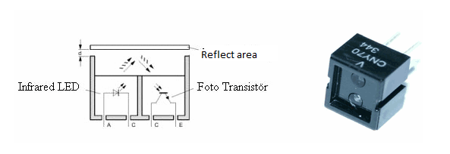 This sensor includes one transmitter (IR infrared Led) and one receiver (fototransistor).The CNY70 works with reverse logic.When the light, Which was produced by IR, reflects from the reflector area and then the base ( B ) of transistor is activeted. With this action the collector ( C ) and emitter ( E ) pass the transmission and act as a close switch  anahtar kapali so current flows throw the 5V to 0V. When it senses white line it’s output is 0 If there is no reflected light it acts open switch  anahtar acik therefore it’s output will be 5V.

*figure 5, CNY70 Sensor*

* **74HC14 (Schmitt trigger )**

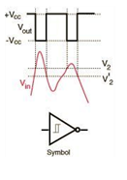

74HC14 Schmitt trigger convertsAnalog signal to digital.When the input is higher than a certain chosen threshold, the output is low; when the input is below a different (lower) chosen threshold, the output is high; when the input is between the two, the output retains its value. When the CNY70 sensor senses the white line it sends 0V to input of the 74HC14 and then 74HC14 converts it logic 1 (5V) and send it to PIC to decide. If the line is black, sensor send 5V to 74HC14 and 74HC14 converts it logic 0 (0V) and send it to PIC to decide on the otherhand 74HC14 provides PIC to work stabile.

*figure 6, 74HC14 (Schmitt trigger)*

* **Components of Sensor Circuit**
* 3 x CNY70 Sensor
* 3 x 100 Ώ Resistor
* 3 x 47 k Resistor
* **Tips About Sensor**

The placement of sensors is very important generally sensors are placed in front of the car. Placement can be ‘V’ or line. We suggest line shape.

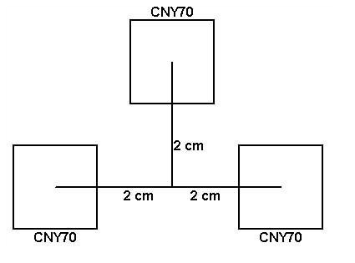 

*figure 7, Placement of Sensors*

* **Motor Interface and Control Circuit**

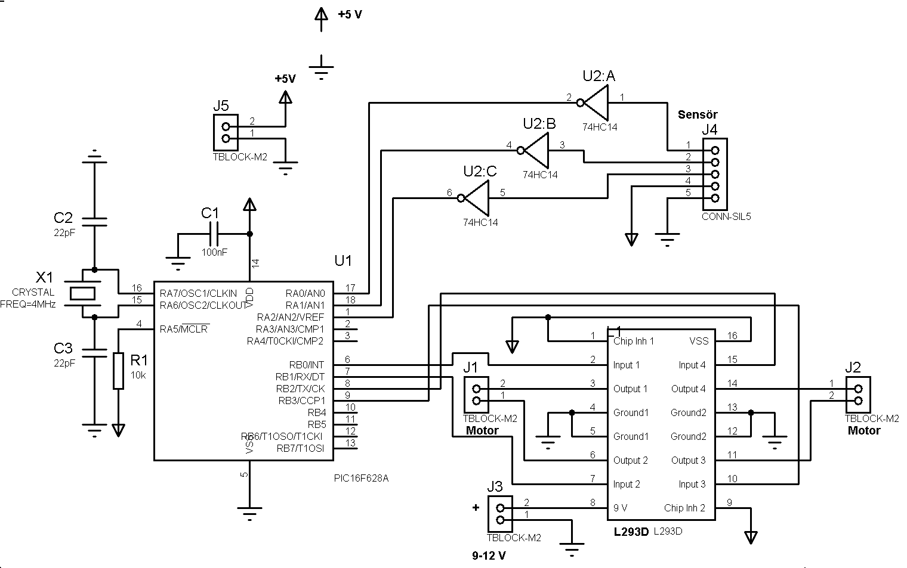

*figure 8, Control Circuit*

The control unit is the microprocessor part of the robot. The microprocessor takes the input signals from the sensors, use them in its program and make decision of the next movement of the line follower robot to follow the path. The output signals are transfered to the motor driver parts of robot. The most commonly used microprocessors are the pic microprocessors produced by microchip.



*figure 9, Printed Control Circuit*

* **PIC 16F628A**

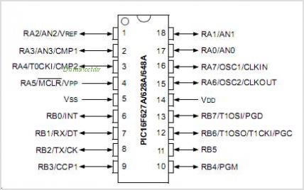 We can simulate this system like sensor to eyes, microprocessor to brain , motors to arms or legs so microprocessor is the most important part. PIC can be programmed in different language like Assembly, Basic, C. Before using PIC16F628A we must take a look datasheet of PIC and learn where it’s inputs , outputs ,usefull pins and features. You can find the datasheet end of the notes and learn reading of it.

*figure 10, PIC 16F628A*

* **L293D (Motor Interface)**

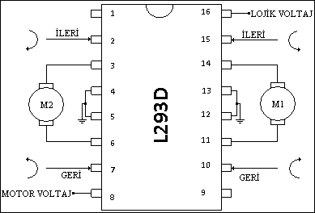 We need motor control unit because PIC provides us max. 25mA output but it is not enough to drive the motors so it must be increased.For this job motor control unit is used. This unit has transistors, logic gates and diodes.L293D provides us 600mA This chip enables you to take 4 outputs and turn them into 2 that can be reversed**.** Note that the chip can get quite warm, but it is designed for that. You can control 2 motors in both directions instead of 4 in only one direction.

*figure 11, L293D (Motor Control Unit )*

* **Crystal Oscillator**

PIC needs oscillator to work. It creates clock signal and this signal executes to uploaded PIC program. The freequency of this signal effects the speed of reading codes. When the frequency increase the working speed of PIC increase. For this robot and PIC 4mHZ oscillator is enough for us.

* **Capacitor**

Capacitor can be used for different purposes in here it filters theinstantaneous ascension or landing at the voltaj source and it provides stabile electric current so the components of the circuit takes less damage.

* **Components of** **Motor Interface and Control Circuit**
* 1 x PIC16F628A
* 1 x L293D
* 1 x 74HC14
* 2 x 18’ Socket for (PIC)
* 1 x 16’ Socket for (L293D)
* 1 x 14’ Socket for (74HC14)
* 1 x 4mHZ Crysistal oscillator
* 2 x 22pF seramic capacitors
* 1 x 100nF seramic capacitors
* 1 x 10k resistor
* 4 x 2’li klemens (Terminal)
* 2 x disli kutulu DC motor
* 1 x sarhoj wheel
* 2 x wheels
* **Voltage Regulator Circuit**

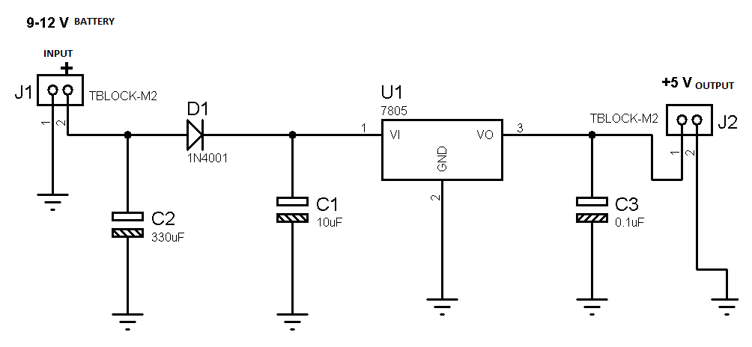

This circuit provides 5 volt for the microcontroller

*figure 12, Voltaj Regulator Circuit*

**

*figure 13,Printed Voltaj Regulator Circuit*

* **7805**

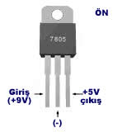

It gives 5 volt and it may warm up quickly in high current.

*figure 14, 7805*

* **Components of** **Voltage Regulator Circuit**
  + 1 x 7805
  + 1 x 330 µF capacitor
  + 1 x 10 µF capacitor
  + 1 x 0.1 µF capacitor
  + 1 x 1N4001 diode
  + 2 x 2’li klemens (Terminal)
  + 9-12 volt or 4,8 volt battery1
* **Programming**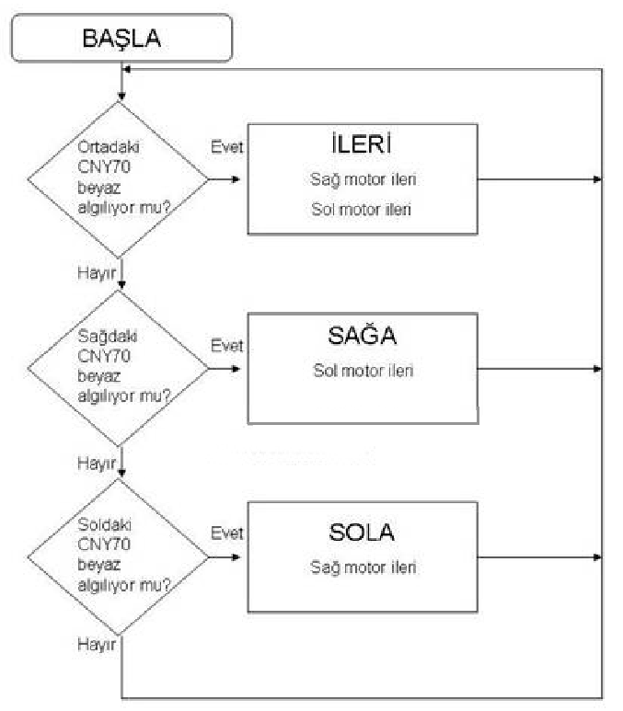

Programming is very important because it decides what will happen if sensors send 1 or 0 and the movement of motors depend on this. For Programming PIC Assembly, PIC Basic, PIC C can be used. For these language you can use MPLAB after you program it you need to the upload the HEX file to PIC.

*figure 15, Simple Flow Cart*

* **Mechanical Part**

Mechanical part is important like other parts. It effects the performance of the robots.Mechanical part must be design very carefully.For designing of the robot’s mechanic we can use many different tecnics.First of all we can use a toy car.These cars have a drive system which is called - *figure 16, Mechanical Part a* ackerman steering.In this driving system motion provides with rear wheel and we have another motor for rotation in front wheel.In this system robot can not turn hairpin bend.In our system we will use a drinker wheel an two independent motors from each other in back side.In this system robot will turn thaks to fast differences between back wheels.This system called differential driving system.



*figure 16, Mechanical Part b*

* **Step By Step Making a Line Follower Robot**

1. Program the PIC by looking at the circuit and datasheet of 16F628A use MPLAB
2. Draw the circuits with Proteus
3. At Proteus send the HEX files to PIC and create similation
4. Observe is it working or not ?
5. After similation, establish the printed circuit (Baski Devresi)
6. Place the components on the printed circuit in right way and solder them
7. Join the circuits to the mechanic part

* **Assembly Codes**

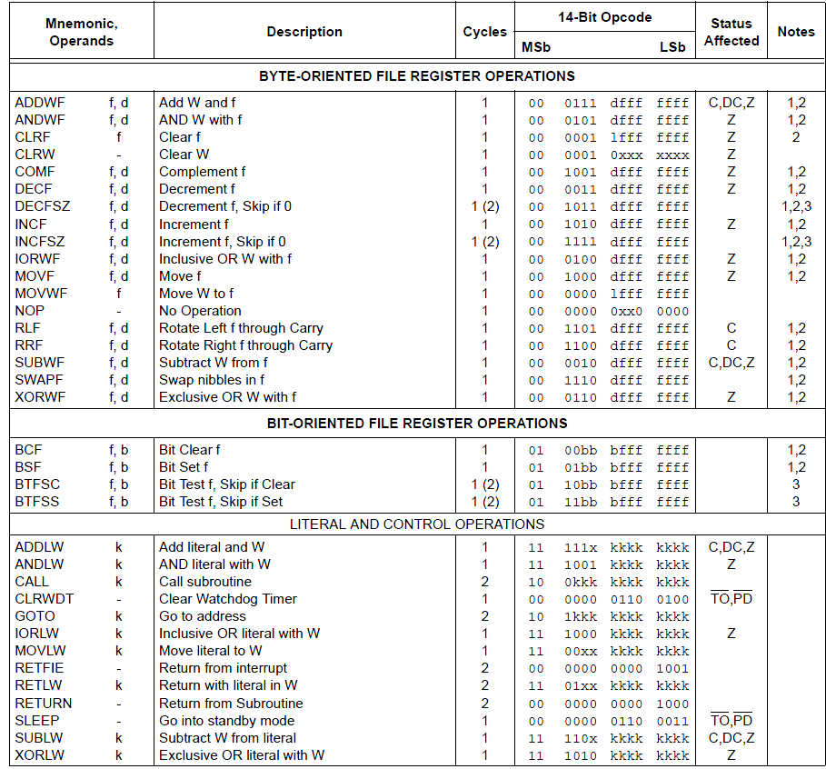

*figure 17, Assembly Codes*